Ideation Phase
Brainstorm & Idea Prioritization Template

Date | 31 January 2025
Team ID | LTVIP2026TMIDS77573
Project Name | Explore with AI: Custom Itineraries for Your Next Journey
Maximum Marks | 4 Marks

Brainstorming was conducted by the team to identify innovative project ideas suitable for a Generative AI internship. The objective was to explore real-world problems where AI could provide practical and scalable solutions. All team members actively contributed ideas related to AI, automation, and user convenience.
During the session, multiple ideas were discussed, evaluated, and expanded collaboratively. The team focused on selecting a project that demonstrates Generative AI capabilities, solves a real problem, and is feasible within the internship timeline.
Reference: https://www.mural.co/templates/brainstorm-and-idea-prioritization
Step-1: Team Gathering, Collaboration and Select the Problem Statement


Step-2: Brainstorm, Idea Listing and Grouping
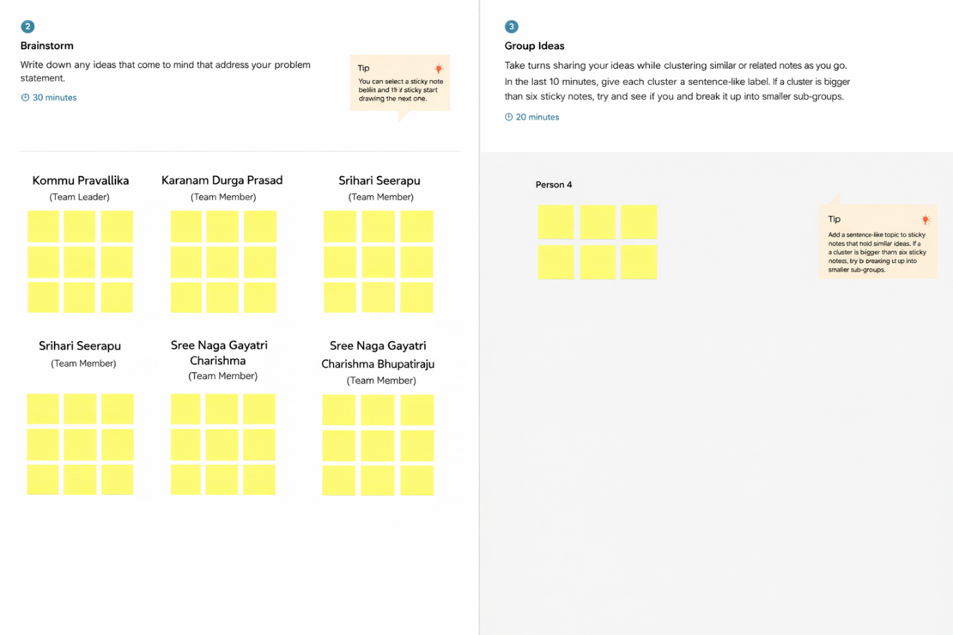

Step-3: Idea Prioritization


